Nobel Energy Inc.

5.875% Semi-annual Coupon Issue Maturing June 1st, 2024

Shiyu Song, Wenjing Zhao, Zhaochen Gao, Lin Zijian

Professor Matt Marcinkowski

November 9th, 2016

**Executive Summary**

Noble Energy Inc. is a company that specializes in petroleum and natural gas exploration and production.[1] The company issued a callable bond on the maturity date of June 1st, 2024 with a semiannual fixed coupon rate of 5.875%. According to Moody’s and Standard and Poor’s ratings, the bond credit rating for Noble Energy Inc. is Baa3 and BBB respectively, so it has good credit quality and can be considered as a good investment and the credit rating of this bond has not fluctuated too much since its issuing which shows the company has a stable performance.

The current yield to maturity of the bond is 4.849%, which is lower than the coupon rate. Therefore, the bond was purchased at a premium. The yield to maturity is the yield that investors will receive over the modified duration of the bond, which is 6.0209 years. Duration represents a measurement of how long it takes for the price of a bond to be repaid by its internal cash flows. The high duration shows that this bond would have high price volatility and relatively risky. The yield to first call is 4.308%, which is also less than the coupon rate. We can readily observe that investors would receive a lower return if the bond were to be called.

Noble Energy Inc. has similar return on assets and return on equity compared with its main competitor Anadarko in the industry[2], but it has better interest coverage ratio compared with Anadarko. ROA and ROE shows its efficiency of management and profitability. However, compared with the performance of industry leaders, the bond of Noble Energy Inc. is still considered risky, because of its negative ROE and ROA.

Based on analyses of Noble Energy Inc.’s financial statements and industry comparisons, for risk-averse investors, Noble Energy Inc.’s corporate bond may be risky for them to consider.

**Introduction**

Noble Energy is a global company established in 1932 and has reached a great success in production and exploitation of oil and natural gas with a high quality portfolio of both U.S. unconventional and global offshore assets over three continents[3]. Its main goal is to offer safe and responsible exploitation and production of oil and natural gas throughout the world[4]. In addition to this, Noble Energy has been able to efficiently undertake large development projects based on energy discovery. For career in Noble Energy, it emphasizes workforce diversity, leadership and innovation.

In terms of company size, the number of employees in Noble Energy is 2397 in 2015, which is smaller than that in 2013 and 2014[5]. For the asset value, according to Yahoo Finance, the total current assets and the total assets on December 31th 2015 are respectively $2276000 and $24196000[6]. Also, the total liabilities on December 31th 2015 are $13826000, and it continuously increased over the past three years. On the other hand, the net income of Noble Energy decreased from $121400 in 2014 to $-2441000 in 2015[7], which implies that the increased potential risk for investors lending Noble Energy money. For the significance in the industry, Noble Energy has $ 16.04 billion of market capital, which is only 0.39% of total market capital in the industry[8], indicates the influences of its decision-making or growth on the whole industry is not big.

The challenge that Noble Energy faces is the increased long-term debts because of recent outperformance when oil and gas prices went down. Unlike Anadarko, one of the largest independent oil and gas exploration and production company which has an enormously amount of oil reserve in the world, Noble Energy cannot offset its loss of decreased prices by its oil reserve. Another challenge is the environmental protection in the process of exploitation, which also increases the operation cost for Noble Energy. The opportunity that it can seize is the technology advance such as horizontal drilling so that more oil can be exported in the areas where oil could not be drilled in the past. Thus it can increase the oil reserve for Noble Energy with the new technology.

In order to examine the leverage and coverage ratio of Noble Energy, the big competitor Anadarko is also analyzed by comparisons of their financial ratios. For ROA and ROE, Noble Energy has -4.39% and -24.88% respectively[9], and those of Anadarko are almost the same: -4.38% and -23.54% respectively[10]. It indicates that both Noble Energy and Anadarko did not efficiently use the assets or investment to make profit, and generated negative net income and undesirable future expectation. In terms of debt to equity ratio and current ratio on September 30, 2016, Noble Energy has 79.78% and 1.82[11], while Anadarko has 111.44% and 1.57[12]. This means that Anadarko borrows more money to support its operations than Noble Energy does relative to their investment and they are both able to pay short-term and long-term obligations on time. In addition, Noble Energy has an interest coverage ratio of -7.44 (-1956000/263000)[13] whereas Anadarko has a -10.74 (-8864000/825000)[14], which shows that Noble Energy is able to repay the interest on debt more easily.

From the above analysis of their ability to pay debts, they both borrow a lot of money to support business activities, but Noble Energy has stronger ability to repay the interest on debt than its competitor. Thus Noble Energy demonstrates a healthier financial situation in terms of responsibility to make promised payments of bond.

**Bond Issue Characteristics**

Noble Energy, Inc. issued an U.S Corporate bond with coupon rate equals to 5.875% and maturity date on June 1st, 2024, paying coupon payments semi-annually on the December 1st and June 1st every year until maturity. This bond is continuously callable starting June 1st, 2019 with a call price $102.938.[15]

Covenants are design to protect the well being of investors. This includes filling reports on company’s information, limitation on liens, merger and consolidation prohibition.[16] This bond is senior unsecured in terms of ranking for repayment.[17] This indicates that the bond does not have physical assets as collaterals, and the loan payments will be fulfilled before other obligations.

The bond currently had a Baa3 on Moody’s Rating and a BBB on the Standard & Poor’s rating.[18] The rating on Moody’s rating is one level lower than the Standard & Poor’s rating, but both ratings indicate that this bond is in the investment-grade. Hence, this bond is relatively less risky and is considered a good choice for long-term investment. However, Noble was downgraded by Moody’s from Baa2 to Baa3.[19] Due to large amount of liabilities, decrease in net profit and demanding development programs. However, Noble maintained a BBB rating on S&P’s rating. This is because Noble’s management teams are also actively finding solutions to increase company reserves and its technology advance. In addition, the developing programs have important findings in Mediterranean and the deepwater Gulf of Mexico. These finding may boost the revenue of the company. These are all good signs for investors.

**Yields and Duration**

The different yields are important factors when considering whether to purchase a bond or not. First, the nominal yield or coupon rate represents a characteristic of the bond and is listed as a constant. For our corporate bond issued by Noble Energy Inc. the 5.875% nominal yield stands for the percentage of the face value that will be paid out to the investor annually. For a $10,000 face value bond, company has to pay $293.75 semi-annually.

The second one is the current yield. The current yield is pretty similar to the nominal yield, but it gives a better idea about how much the bond is currently yielding. It is calculated by dividing the nominal yield, 5.875% by current trading price 106.46%. This gives us a current yield of 5.519%. The current yield is smaller than the nominal yield because the bond is trading at a premium.

Thirdly, the yield to maturity, or YTM, considers the time value of money. The yield to maturity is the internal rate of return earned by the investor so the investor is able to know the return they can generate if the bond is held until maturity and all payments are reinvested at the same yield until maturity. This enables investors to easily pick among bonds with similar characteristics. Normally, the higher the YTM, the more risky and expensive the bound is. On Noble Energy Inc. the YTM is 4.849%. This was calculated by summing discounted future cash flow at a rate to equal to the invoice price of the bond.

Though YTM is significant when evaluating a bond, some bonds have call provisions that allow the issuer to pay off its debt before maturity at a specified price. The bond we analyzed is callable starting in June 1st, 2019. It is critical to inspect the bond’s yields to call since they might be the real rate of return. The picture below shows details about different calls.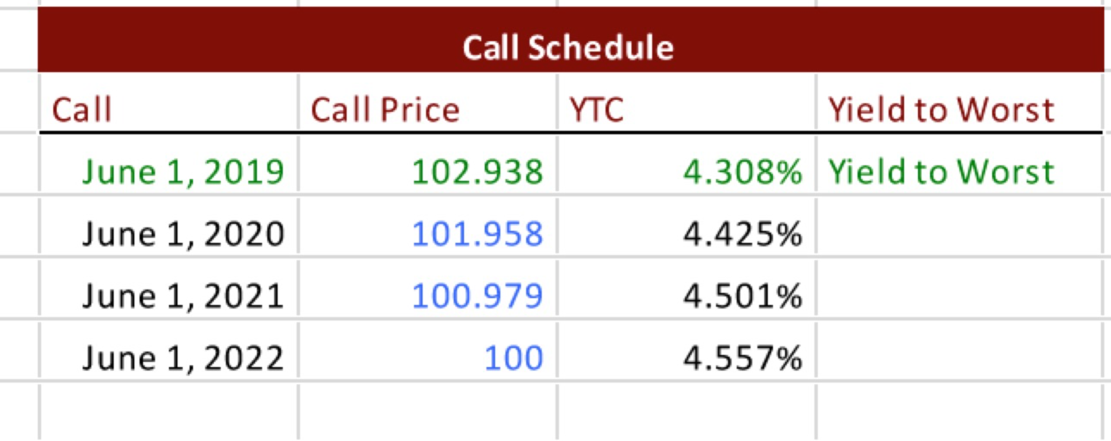

According to the table, when the call date gets earlier the yield decreases due to the loss of coupon payment. To compensate this loss, the issuer has to pay additional premium and accrued interest to the redemption date. The yield to call in 2019 of 4.308% is the worst outcome for the investor. If the yield to call is lower than the yield to maturity, and the interest rate is low, company would be likely to call the bond and replace it with lower coupon rate bond.

Last but not least, the bond’s duration. Duration is the weighted average the times until the maturity of the cash flows. It measures the bond’s price sensitivity to yield. A higher duration indicates that the bond is more sensitive to interest rate changes, and thus more risky. As shown in the Appendix, we calculated the duration to be 6.1668 years. The modified duration, which captures the relative sensitivity of a bond’s price to interest rate fluctuations, is 6.0209 years. We will further discuss about the duration in the Sensitivity Analysis.

**Sensitivity Analysis**

Understanding how the bond price move with the interest rate environment helps one to study the potential risks as well as predict future bond price movements. Generally, the bond price has an inverse relationship with the interest rate. However, their degree of negative correlation varies from bond to bond, thus leading to different risks. Modified Duration helps to determine the correlation between prices and yield, as it measures the relative sensitivity of a bond’s price to interest rate fluctuations. Modified Duration is also the slope of the price yield curve present below.

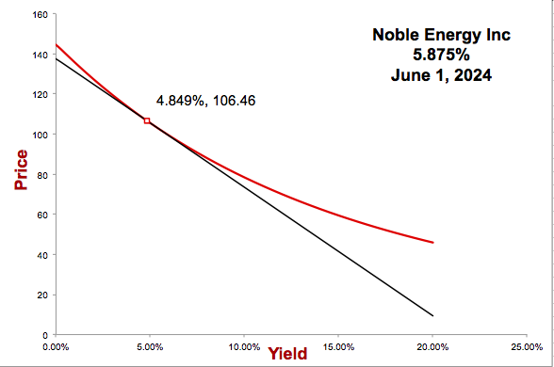From the graph, we can see that when yield to maturity equals to 4.849%, the bond price is $106.46. The modified duration is 6.0209 years. This indicates that with 1% change in the interest rate, there is 6.0209% decrease in the price of the bond. This is relatively high as the bond matures in 8 years. Thus, this bond is considered sensitive to the change in the interest. Buying this bond, investors are subject to a high interest risk.

From the graph, we can see that the slope of graph is negative. This represents the negative correlation between price and yield. In addition, from the tangent modified duration line in the price yield curve, we can tell that the further away from the maturity date, the higher risk the investors are subject to due to the change in interest rate.

**Conclusion**

After analyzing the Noble Energy Inc.’s corporate bond, we would not recommend this bond to a risk-averse investor. Noble Energy Inc. has a relatively low interest coverage ratio. It indicates a greater risk of default and it may have lesser amount of earning available to make payments. It also means the company is less able to handle any increase in interest rates. Furthermore, the bond is unsecured, representing that the company is not backed by any type of collateral.

Comparing this bond to other bonds with similar characteristics, we can see that the price matched its yield. For OMEGA HEALTHCARE INVS INC[20], its bonds with similar maturity date and ratings are trading at a price of 104.62% with a coupon rate of 5.785%. For the exact same coupon rate, it has slightly lower price than Noble Energy Inc. Under such circumstance, Noble Energy Inc. is not underpriced or overpriced.

One of the riskiest parts of buying this bond comes from its duration. The modified duration is 6.0209 years, which is considerably high. This means that the bond has more than 6 years of interest rate risk before an investor will realize its value. However, the yield to first call is 4.308%, which is less than the coupon rate. If the bond were to be called, investors would receive lower return. As, Noble Energy Inc. is not financing with a significant amount of debt and able to repay its debt, so it is likely that they will be willing to call the bonds before 2024 and be able to pay for the bonds.

Considering the financial health of Noble Energy Inc. and all other factors analyzed, we would not recommend a risk-averse investor to invest in their corporate bond.

Appendix A: Bond Prospectus

424B3 1 d943440d424b3.htm 424B3

**Table of Contents**

**Filed Pursuant to Rule 424(b)(3)**

**Registration No. 333-205313**

**PROSPECTUS**



**Noble Energy, Inc.**

**Offers to Exchange**

**All Outstanding Senior Notes of the Series Specified Below**

**and Solicitation of Consents to Amend the Related Indentures**

**Early Consent Date: 5:00 p.m., New York City Time, July 13, 2015, unless extended**

**Expiration Date: 11:59 p.m., New York City Time, July 27, 2015, unless extended**

We are offering to exchange any and all senior notes of the following series issued by Rosetta Resources Inc. (“Rosetta”) validly tendered (and not validly withdrawn) and accepted for exchange by us for senior notes to be issued by us as described in, and for the consideration summarized in, the table below.

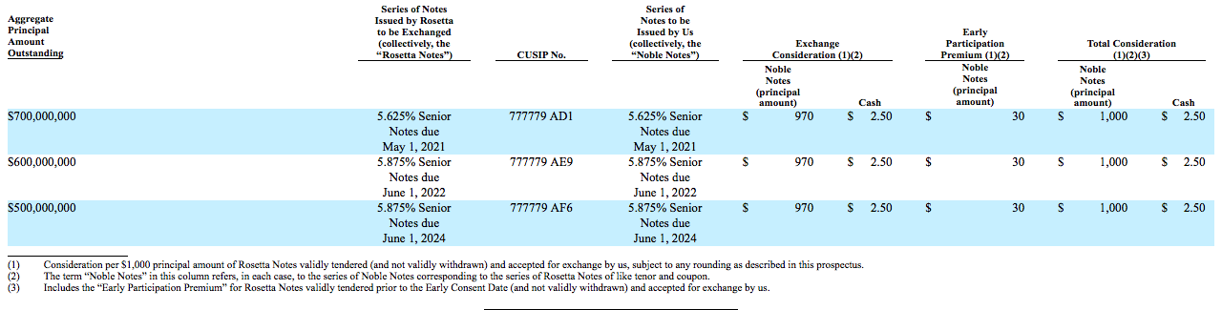

**This investment involves risks. Prior to participating in any of the exchange offers and consenting to the proposed amendments to any of the Rosetta Indentures, please see the section entitled “Risk Factors” beginning on page 25 of this prospectus for a discussion of the risks that you should consider in connection with your investment in the Noble Notes.**

**Neither the Securities and Exchange Commission nor any state securities commission has approved or disapproved of these securities or determined if this prospectus is truthful or complete. Any representation to the contrary is a criminal offense.**

None of Noble, Rosetta, the exchange agent, the information agent, the Rosetta Trustee, the Noble Trustee or the dealer managers makes any recommendation as to whether holders of Rosetta Notes should exchange their notes in any of the exchange offers or deliver consents to the proposed amendments to any of the Rosetta Indentures, and no one has been authorized by any of them to make such a recommendation.

The dealer managers for the exchange offers and solicitation agents for consent solicitations are:



Appendix B: Yield to Maturity

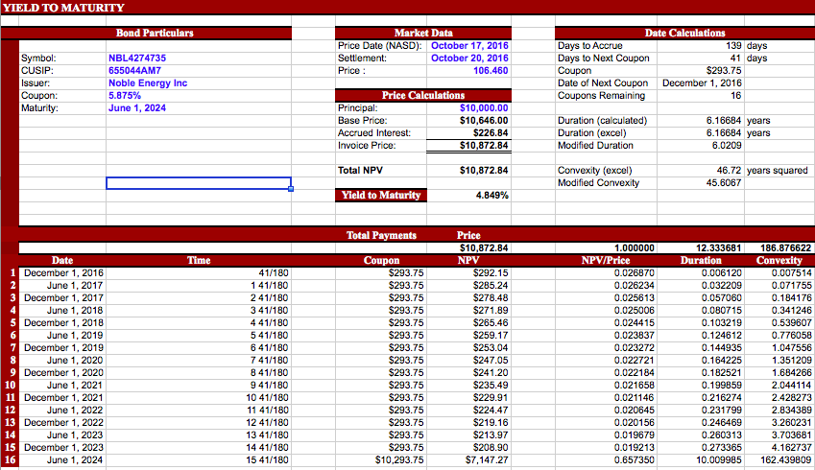

Appendix C: Yield to Call

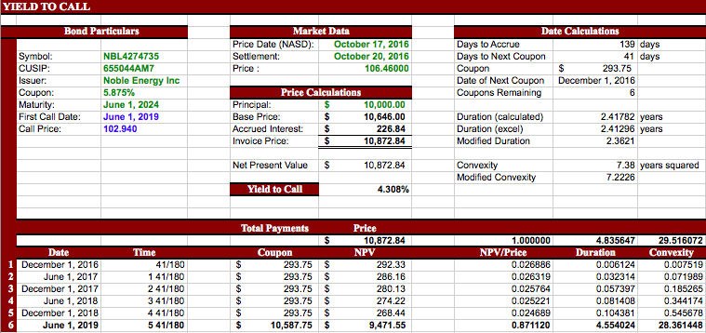

Appendix D: Call Schedule

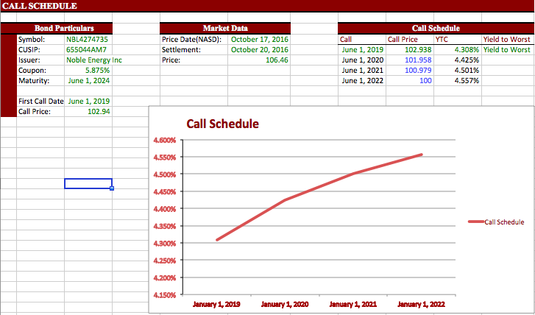

Appendix E: Price Yield Curve

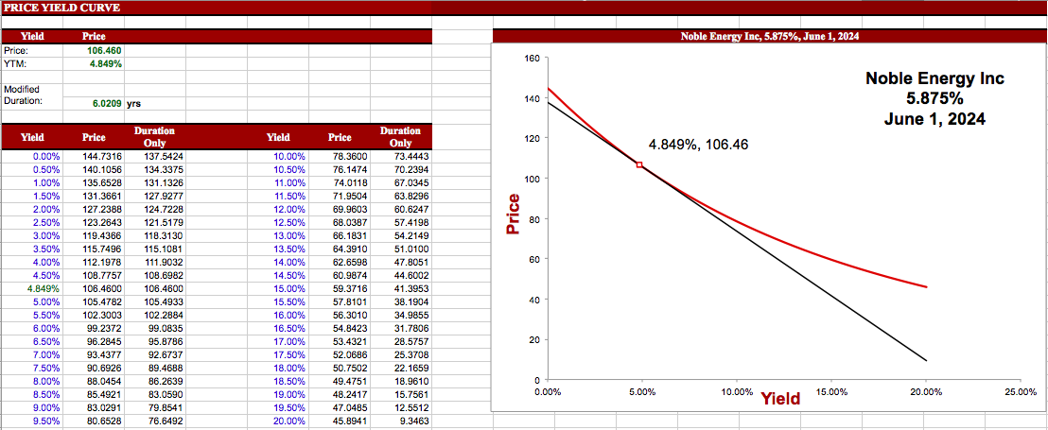

1. Noble Energy Inc., “Our Value”, Assessed Nov 8th, 2016.

   <http://www.nobleenergyinc.com/about-us/our-value-50.html>
2. Mergent Online, Noble Energy Inc., Assessed Nov 8th, 2016. <http://www.mergentonline.com.proxy2.library.illinois.edu/companyfinancials.php?pagetype=ratios&compnumber=6052>
3. Noble Energy. “Our Value.” Accessed November 8, 2016

   <http://www.nobleenergyinc.com/fw/main/Our-Value-50.html>
4. Noble Energy. “Our Mission.” Accessed November 8, 2016

   <http://www.nobleenergyinc.com/about-us/our-mission-68.html>
5. Noble Energy. “Performance Data.” Accessed November 8, 2016

   <http://responsibility.nobleenergyinc.com/performance-data/>
6. Yahoo Finance. “NBL.” Accessed November 8, 2016

   <http://finance.yahoo.com/quote/NBL/financials?p=NBL>
7. Yahoo Finance. “NBL.” Accessed November 8, 2016

   <http://finance.yahoo.com/quote/NBL/financials?p=NBL>
8. Yahoo Finance. “NBL.” Accessed November 8, 2016

   <http://finance.yahoo.com/quote/NBL?p=NBL>
9. Yahoo Finance. “NBL.” Accessed November 8, 2016

   <http://finance.yahoo.com/quote/NBL/key-statistics?p=NBL>
10. Yahoo Finance. “APC.” Accessed November 8, 2016

    <https://finance.yahoo.com/quote/APC/key-statistics?p=APC>
11. Yahoo Finance. “NBL.” Accessed November 8, 2016

    <http://finance.yahoo.com/quote/NBL/key-statistics?p=NBL>
12. Yahoo Finance. “APC.” Accessed November 8, 2016

    <https://finance.yahoo.com/quote/APC/key-statistics?p=APC>
13. Yahoo Finance. “NBL.” Accessed November 8, 2016

    <http://finance.yahoo.com/quote/NBL/financials?p=NBL>
14. Yahoo Finance. “APC.” Accessed November 8, 2016

    <https://finance.yahoo.com/quote/APC/financials?p=APC>
15. Noble Energy Inc. "Offer Exchange Prospectus."P.76. 2015 SEC EDGAR System. Accessed November 08, 2016.

    <https://www.sec.gov/Archives/edgar/data/72207/000119312515254968/d943440d424b3.htm>
16. Noble Energy Inc. "Offer Exchange Prospectus."P.57-73. (2015). SEC EDGAR System. Accessed November 08, 2016.

    <https://www.sec.gov/Archives/edgar/data/72207/000119312515254968/d943440d424b3.htm>
17. Noble Energy Inc. "Offer Exchange Prospectus."P.7. (2015) SEC EDGAR System. Accessed November 08, 2016.

    <https://www.sec.gov/Archives/edgar/data/72207/000119312515254968/d943440d424b3.htm>
18. FINRA. “Bond Detail: Noble Energy Inc.”. Accessed November 8, 2016.

    <http://finra-markets.morningstar.com/BondCenter/BondDetail.jsp?ticker=C635837&symbol=NBL4274735>
19. Moodys.com. "Moody's Concludes Reviews for 9 US Baa-rated E&P Companies and 2 MLPs." (2016). Accessed November 08, 2016.

    <https://www.moodys.com/research/Moodys-concludes-reviews-for-9-US-Baa-rated-EP-companies--PR_344095>
20. Finra, OMEGA HEALTHCARE INVS INC, Assessed on Nov 8th, 2016

    <http://finra-markets.morningstar.com/BondCenter/BondDetail.jsp?ticker=C581919&symbol=OHI3891158>